|  |  |  |  |  |
| --- | --- | --- | --- | --- |
| Plant Cell Mitosis | Animal Cell Mitosis  (see iPads/green book) | Diagram of Chromosomes  (with genes) | Number of Chromosomes | Single or Double |
|  |  |  |  |  |
|  |  |  |  |  |
|  |  |  |  |  |
|  |  |  |  |  |
|  |  |  |  |  |
|  |  |  |  |  |

[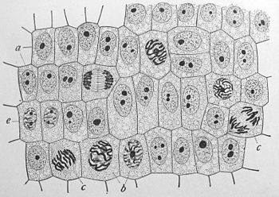](http://www.google.com/url?sa=i&rct=j&q=mitosis&source=images&cd=&cad=rja&docid=H8F3awzEIvRHmM&tbnid=5hkzYxLMWTyfiM:&ved=0CAUQjRw&url=http://en.wikipedia.org/wiki/Mitosis&ei=a4kaUaaVKMOLqgGUuoH4Bw&bvm=bv.42261806,d.aWc&psig=AFQjCNHWiQMvkW1LawQ2lr5pWBAmU9Kr3w&ust=1360780008831824)

Label the diagram to the right with the following:

1. Each mitosis phase
2. Chromosomes
3. Cell wall
4. Nuclear membrane

Questions:

1. What type of cells are shown in this picture and how can you tell?
2. Compare the cell marked “c” to the cell next to it (left):

**Questions continued:**

3. Explain how the chromosomes line up during mitosis. This is very important to understanding how the new cells are identical to the original cell:

4. Why is mitosis important? (give two examples of where real mitosis is going on right now!)