Genetics and Mitosis Study Guide:
- Draw a picture that shows the relationship of the following things:
DNA, Chromosomes, nucleotides, gene, allele.
- Fill in this chart using your genetics guru page:
Term | Definition | Example
Genotype
Phenotype
Homozygous
Heterozygous
Dominant
Recessive
Allele

- Label the Cell Cycle with what happens at each phase…
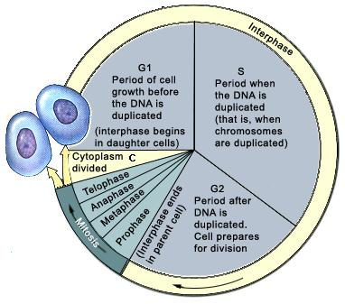

- Explain why cells must divide:

- Imagine you had an animal that had 4 pairs of chromosomes in all of their cells…how many chromosomes would they have during metaphase?

- Imagine you can see the genes on one particular chromosome pair. This pair is heterozygous for brown eyes (B for brown; b for blue), and homozygous recessive for hitchhikers thumb (Assume NO Hitch hiker’s thumb is dominant to hitchhikers thumb). Draw what would happen to these chromosomes in Prophase, Metaphase, Anaphase and Telophase:

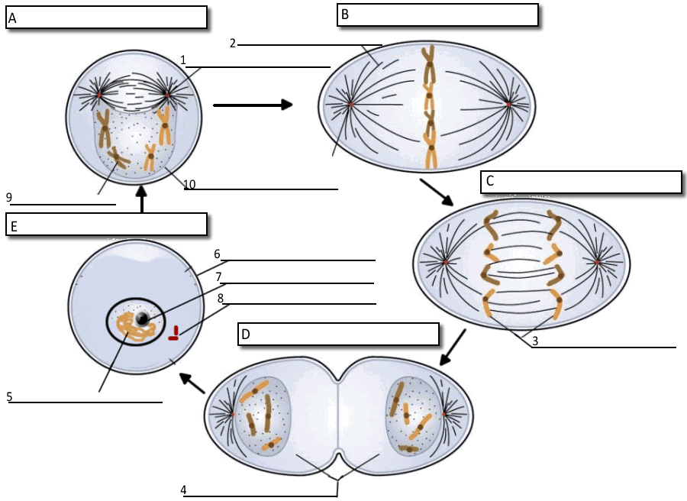

- Label the diagram above with the phases of mitosis as well as the parts of the cell involved (phases are letters) http://www.biologycorner.com/worksheets/cellcycle_labelme_key.html
Do the last three on an attached page please…
- Choose one to demonstrate you know (genotype, phenotype, homozygous, heterozygous, allele, dominant, recessive):
- Write about your newborn case study…how they got the disorder and what it means.
- Make up your own trait for any living thing you choose and explain how it would be carried in the genes.
- Compare different types of stem cells…
- Totipotent
- Multipotent
- Pluripotent
- Induced pluripotent

- Write about the potential future uses of stem cells (choose 3).

