Living Lab #1 (Weise Example)
Problem: Do the dots breathe?
Gather Information:
CO₂ is given off by all living things when they breathe (cellular respiration).
Dots were found in cholera sample but not in healthy stool sample.

Hypothesis:

Test

Results:

 | Healthy Stool | Cholera Stool
BTB color | Blue | Yellow

Conclusion:
The hypothesis that the dots breathe was _____________by the test. We tested this by

We found
We know this because
Next time,

Living Lab #2 (example)
Problem: Do the dots eat?
Gather Information:
CO₂ is given off by all living things when they breathe (cellular respiration).
Dots were found in cholera sample but not in healthy stool sample.
Dots gave off CO₂in the breathing lab.
Petri dishes are used to grow microorganisms.
Hypothesis: Dots eat
Test
- Mix a 1ml sample of dots with 1ml of glucose water.
- Mix another 1ml sample of dots with 1ml regular water.
- Use an inoculating loop to add each sample to the petri dish (one half is dots with sugar; the other half is dots with regular water).
- Let the sample grow for 48 hours in the classroom.
Results:
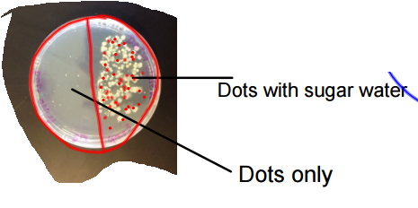
Conclusion:
The hypothesis that the dots eat was confirmed by the test. We tested this by inoculating a petri dish with two samples. One side of the dish was dots with sugar water, while the other side was dots with regular water. We found several large colonies on the dots with sugar water side but few tiny colonies with dots with regular water. This means that the dots ate the sugar water and grew. We know this because when we started the petri dish there were no visible colonies on the dish. After the dots had time to grow we could see lots of colonies but only on the sugar side. Next time we will use two different petri dishes. It seems possible that there was some cross contamination.

Are the Dots Alive Summary Paper:
(keep in mind you should use your own words and take out all blanks!)
In Biology we have been investigating the cholera epidemic in Haiti.

All living things…

We think the dots are __________because we tested the characteristics of life in class. The first characteristic we tested was breathing.

Next we tested reproduction. We found___________________________. This means __________________. We know this because______________________________________________________________________________

