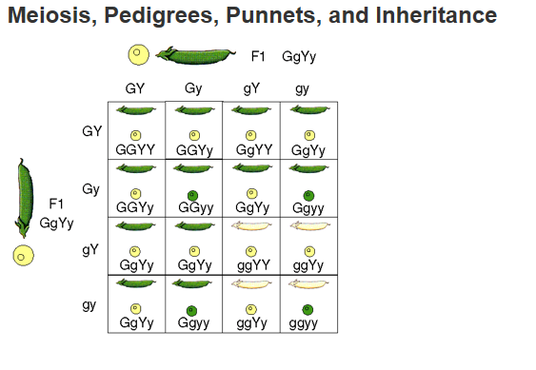

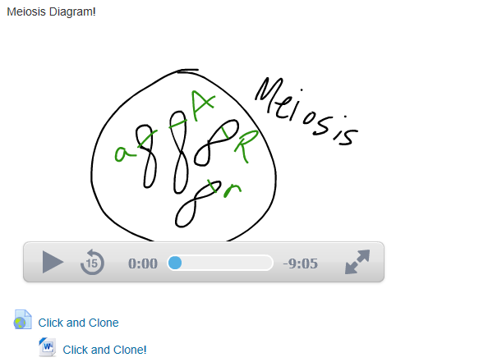

Download, do and print the click and clone!

1. Make up work IF you’ve been gone (or slacking)…

Meiosis Diagram…watch movie and draw chromosomes in the boxes on the handout as you go…

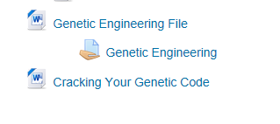

Exra time? Here’s a thing for next week.

Genetic Engineering is a Homework check for Wednesday of next week.

Cracking the code is a movie we will not have time to watch! But it’s super cool.