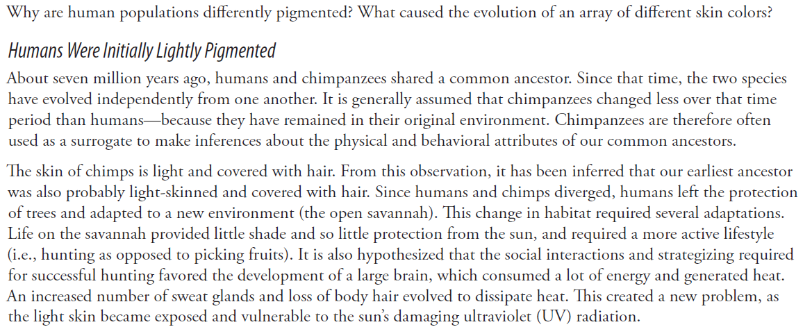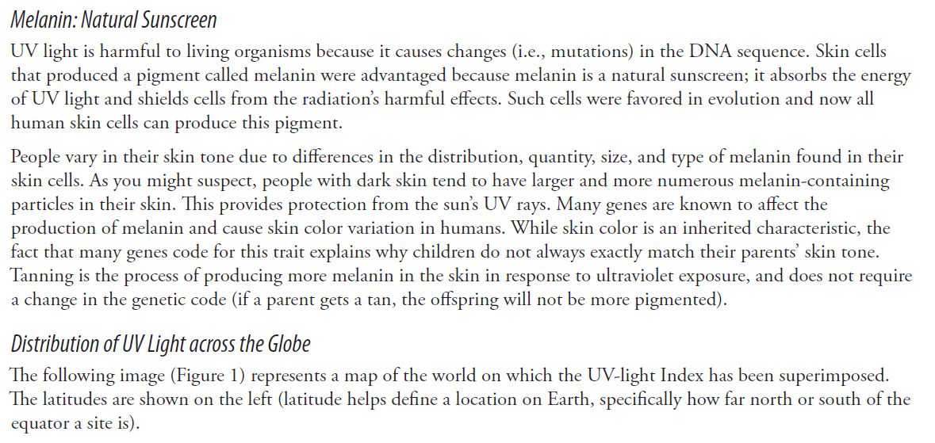
- Which latitude receives the greatest amount of UV light?
- Which latitude receives the least amount of UV light?
- Describe the pattern you observe on the map of the amount of UV light reaching the earth.
- Based on the data, make a claim about where might you expect to find the mostly lightly pigmented and most darkly pigmented peo0ple on the planet. Be specific.
- Provide evidence for your claim in #4.

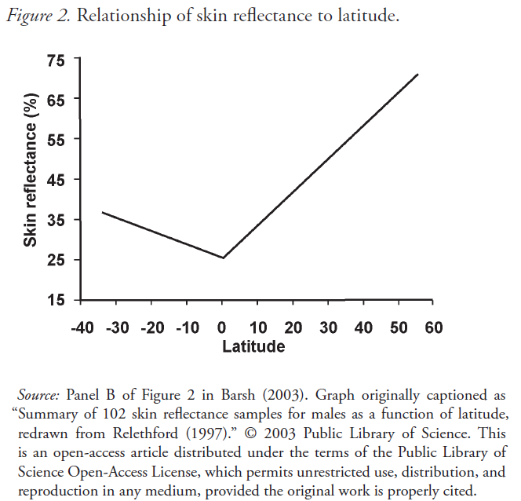
- Describe the pattern of skin reflectance distribution throughout the globe.
- Evaluate your claim using the graph above. Does this add evidence to your claim or refute your claim? Explain.
- Make a new claim about why different skin colors have evolved. Based on what you know what factor is the most likely to exert a selective pressure on skin color?
