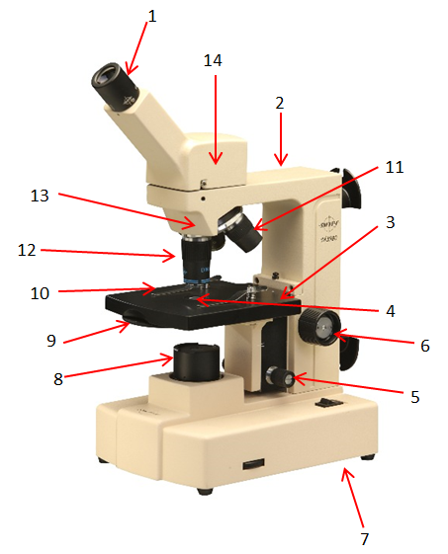

The Compound Microscope
One of the most essential tools in the study of biology is the microscope. With the help of different types of microscopes, biologists have developed detailed concepts of cell structure and function. The type of microscope used in most biology classes is the compound microscope. It contains a combination of lenses and can magnify objects normally unseen with the unaided eye.
The eyepiece is located in the top portion of the microscope. This lens usually has a magnification of 10X. A compound microscope usually has two other interchangeable lenses. These lenses, called objective lenses, are at the bottom of the body tube on the revolving nosepiece. By revolving the nosepiece, either of the two objectives can be brought into direct line with the body tube.
The shorter objective is low power in its magnification, usually 4X. The longer one is high power, usually 10X and 40X. The magnification is always marked on the objective. To determine the total magnification of a microscope, multiply the magnifying power of the eyepiece by the magnifying power of the objective being used. For example, the eyepiece magnifying power, 10X, multiplied by the low power objective, 4X, equals 40X. The total magnification is 40X.

Microscope Parts and Their Functions

- Eyepiece Contains a magnifying lens
- Arm Supports the body tube
- Stage Supports the slide being observed
- Opening of the Stage Permits light to travel up to the eyepiece
- Fine Adjustment Moves the stage slightly to sharpen the focus
- Coarse Adjustment Moves the stage up and down for focusing
- Base Supports the microscope
- Illuminator Produces light or reflects light up through the body tube
- Diaphragm Lever Regulates the amount of light entering the body tube
- Stage Clips Hold the slide in position
- Low Power Objective Provides a magnification of 10X
- High Power Objective Provides a magnification of 40X or 43X
- Revolving Nosepiece Used to change objectives
- Body Tube Maintains distance between lenses

A microscope also produces clear contrasts to enable the viewer to distinguish between objects that lie very close together. Under a microscope the detail of the objects is very sharp. The ability of a microscope to produce contrast and detail is called resolution, or resolving power. Although microscopes can have the same magnifying power, they can differ in resolving power.
Learning the name, function, and location of each of the microscope’s parts is necessary for proper use. Use the following procedures when working with the microscopes.
- Remove the microscope from its storage area by placing one hand beneath the base and grasping the arm of the microscope with the other hand.
- Raise the body tube by turning the coarse adjustment knob until the objective lens is about 2 centimeters above the opening of the stage.
- Revolve the nosepiece so that the low-power objective (4X) is directly in line with the body tube. A click indicates that the lens is in line with the opening of the stage.
- Look through the eyepiece and switch on the lamp so that a circle of light can be seen. This is the field of view. Moving the lever of the diaphragm permits a greater amount of light to come through the opening of the stage.
- Place a prepared slide on the stage. Position the specimen over the center of the opening of the stage. Fasten the stage clips to hold the slide in position.
- Look at the microscope from the side. Carefully turn the coarse adjustment knob to raise the stage until the low power objective almost touches the slide.
- Look through the eyepiece and observe the specimen. If the field of view is out of focus, use the coarse adjustment knob to lower the stage while looking through the eyepiece.
- Move up to medium power and focus the specimen again.
- To view the specimen under high power, revolve the nosepiece until the high power objective is in line with the body tube and clicks in place.
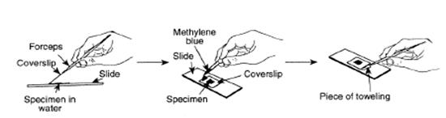
- Look through the eyepiece and use the fine adjustment knob to bring the specimen into focus.
- After every use, remove the slide. Clean the stage of the microscope and the lenses with lens paper. Do not use other types of paper to clean the lenses, as they may scratch the lenses.

Preparing a Wet-Mount Slide
- Obtain a clean microscope slide and cover slip. A cover slip is very thin, permitting the objective lens to be lowered very close to the specimen.
- Place the specimen in the middle of the microscope slide. The specimen must be thin enough for the light to pass through it.
- Using an eyedropper, place a drop of water on the specimen.
- Lower one edge of the cover slip so that it touches the side of the drop of water at a 45° angle. The water will spread evenly along the edge of the cover slip. Using a dissecting needle or probe, slowly lower the cover slip over the specimen and water. Try not to trap any air bubbles under the cover slip. Air bubbles interfere with the view of the specimen. If air bubbles are present, gently tap the surface of the cover slip over the air bubble with a pencil or eraser.
- Remove any excess water at the edge of the cover slip with a piece of water of paper towel. If the specimen begins to dry out, add a drop of water at the edge of the cover slip.

Staining Techniques
- Obtain a clean microscope slide and cover slip.
- Place the specimen in the middle of the microscope slide.
- Using an eyedropper, place a drop of water on the specimen.
- Lower one edge of the cover slip so that it touches the side of the drop of water at a 45° angle. The water will spread evenly along the edge of the cover slip. Using a dissecting needle or probe, slowly lower the cover slip over the specimen and water.
- Add a drop of stain at the edge of the cover slip. Using forceps, touch a small piece of lens paper or paper towel to the opposite edge of the cover slip. The paper causes the stain to be drawn under the cover slip and stain the cells. Some common stains are methylene blue, iodine, fuchsin, and Wright’s stain.

